***CIS 311 - Assignment 7***

So a great way to understand drag and drop is by writing a game. I am asking you to implement a turn based version of Tic Tac Toe. This game will work by allowing the X on the right, or O on the left to be dragged onto the 3 x 3 board area. If there is nothing currently in the intended drop location, set the background green to indicate it is a valid move; if something is already in the drop location, set the background red to indicate a drop is not permitted. Make sure that you change the background color back to normal upon a successful drop or mouse leave event. Here’s the board after a win:

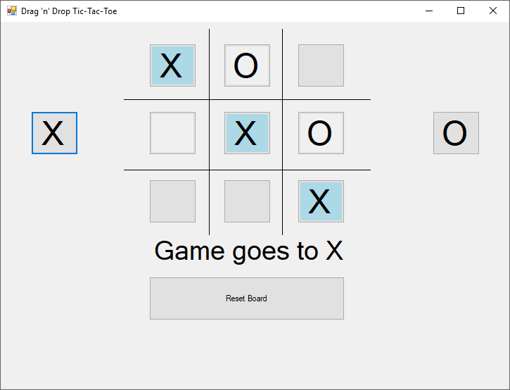

After each drop, your program should check to see if there is a tie or if a player won. If the game is over, you should display an appropriate message citing that a draw occurred or that either player X or player Y won. If there is a win, mark the winning squares on the board.

Obviously if there is a draw, you don’t have to worry about much, since there would never be a valid drop location due to all of the spots being filled, so if a player tried to make another move, it wouldn’t be allowed. However after a win, your code should be written in such a way that neither player can try moving an X or O onto the board space.

Once a game is over (or at any time actually), the Reset Board button can be pressed which will reset the board back to its normal empty state. By the way, don’t sweat it if you can’t get the lines drawn on the board – if you really want to know how, come see me if it’s bugging you and I’ll explain it.

Complete your assignment and place your entire solution in a zip file, which you will upload to Canvas. Turn in a cover sheet and screenshots of your program’s execution stapled together in that order in class.